**Estimate. Divide and Check. KEEP THE SINGLE DIGIT and use estimation for the quotient.**

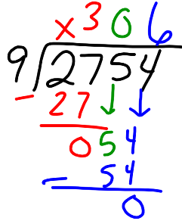**EXAMPLE**

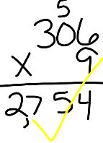**2,754 ÷ 9**

**Keep the 9, and think of multiples of 9. 9, 18, 27, 36, …**

**I could change 2,754 to 2,700 and estimate 2,700 ÷ 9 = 300**

Estimate. Divide and Check.

|  |  |
| --- | --- |
| 614 ÷ 6 | 624 ÷ 8 |
| 3,220 ÷ 4 | 1,027 ÷ 4 |

Estimate. Divide and Check.

|  |  |
| --- | --- |
| 938 ÷ 6 | 762 ÷ 2 |
| 5,654 ÷ 3 | 475 ÷ 8 |

Estimate. Divide and Check.

|  |  |
| --- | --- |
| 671 ÷ 4 | 2,023 ÷ 9 |
| 4,685 ÷ 3 | 948 ÷ 8 |

Estimate. Divide and Check.

|  |  |
| --- | --- |
| 1326 ÷ 4 | 5,868 ÷ 6 |
| 566 ÷ 3 | 3,283 ÷ 9 |